Binary trees can be used for representing abstract data types such as dictionaries and ordered lists. They work well when the elements inserted are in random order. IF it were possible to randomly permute the list of items to be inserted, trees would well with high probability for any input sequence. Balanced tree algorithms re-arrange the tree as operations are performed to maintain certain balance conditions and assure good performance.

**Skip lists** area probabilistic alternative to balanced trees. Skip lists allow quick search, insertion and deletion of elements. It is a linked list with additional pointers such that intermediate nodes can be skipped. It uses a random number generator to make some decisions.

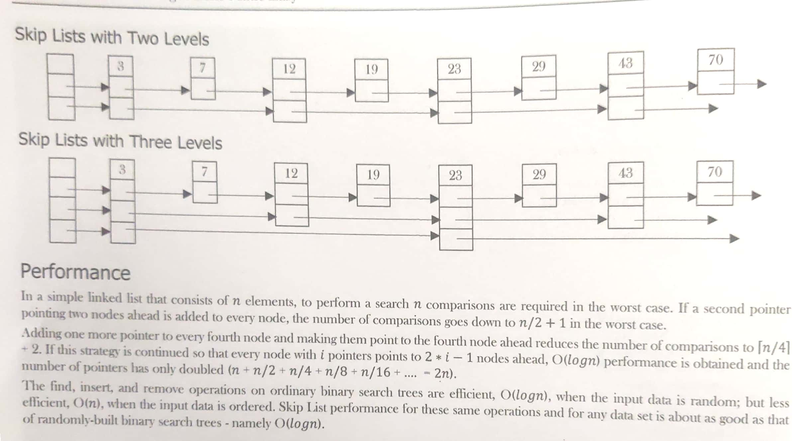

In simple terms, Skip lists are sorted linked lists with two difference:

1. The nodes in an ordinary list have one next reference. The nodes in a Skip list have many next references (also called forward references).
2. The number of forward references for a given node is determined probabilistically.